**RQM_Test_Result_Handler - Automation framework:**

This framework is to create test case execution records and upload results in RQM.

There are 2 version available:

1. TCER generation & Result upload with GUI enable
2. TCER generation & Result upload without GUI

Note: This can also be use with Jenkins.

**Framework folder structure:**

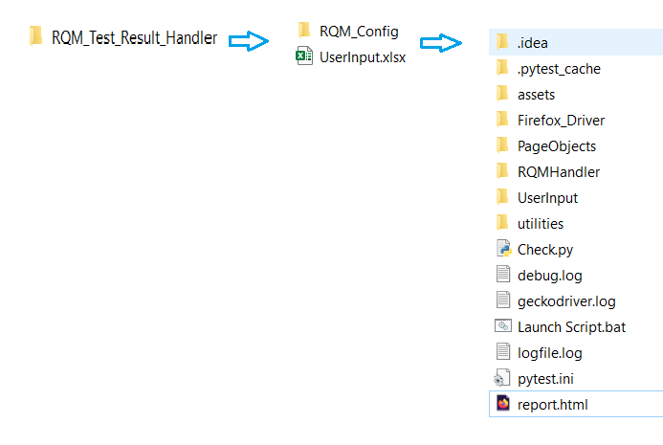

**How to use**:

Step 1: Install python version 3.6 or above

Step 2: Install side packages:

pip install pytest

pip install selenium

pip install pytest-html

pip install openpyxl

pip install lxml

pip install beautifulsoup4

*Environment is ready to use framework* ☺

Step 3: Place folder “*RQM_Test_Result_Handler”* in C drive (C:\)

Step 4: Update “*UserInput.xlsx*” file:

Fill sheet for project specific information required for RQM template:

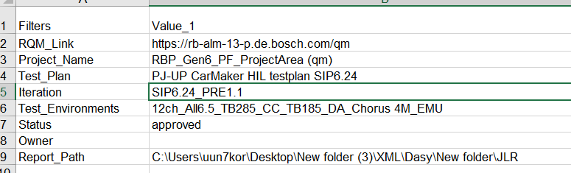

Step 5: Launch script by .bat file (Double click on “*Launch Script.bat*” file)

*It will create test case execution records and upload results in RQM*

Step 6: Test Results uploaded and HTML report is available in folder “*RQM_Test_Result_Handler*”

**For any query**: Please contact: *Sunny Kumar (RBEI/ESD-PP52)*